Progress Report February 17, 2025

Project Title: An ecological and oceanographic baseline to inform offshore wind development over the continental shelf off the coast of New Jersey

Authors: Grace Saba & Josh Kohut

Project Overview:
New Jersey has set a goal to procure half of its energy from renewable resources by 2030. With offshore wind construction scheduled to begin in the next couple years, it is critical that oceanographic and ecological baseline monitoring begin immediately. In this 2-year project, a glider-based program will simultaneously map oceanographic and ecological parameters that will inform each of the New Jersey Offshore Wind Research and Monitoring Initiative’s (RMI) research priorities. The project consists of glider deployments (11 per year), data management, and data analysis and product development relevant to RMI research priorities.

A seasonal baseline survey is being conducted with a pair of gliders deployed in each season over two years with a full complement of available sensors to simultaneously map oceanographic and ecological variables. The zig-zag glider missions cover an area from Sandy Hook down to Atlantic City, from near shore extending out across the shelf. This ensures that the monitoring occurs both on established long-term transects for historical context and within offshore wind lease areas. To accommodate the larger sensor suite and mitigate interference between active and passive sensors this approach utilizes two gliders paired for each seasonal mission. One glider is equipped with a CTD to determine water depth, temperature, salinity, and density; an optics puck measuring chlorophyll-a, backscatter, and colored dissolved organic matter (CDOM) fluorescence; an optode measuring dissolved oxygen; and a DMON passive acoustics sensor for marine mammal monitoring and detection. The second glider is equipped with an optics puck and an Acoustic Zooplankton Fish Profiler (AZFP) multi-frequency echo sounder for active acoustic detection of pelagic organisms. Similar to the first glider, the second glider has a CTD, but this CTD package also includes an integrated pH sensor for ocean acidification applications. Both gliders carry a fish telemetry receiver to track tagged species moving through the region. In addition to these paired seasonal missions, we will deploy a third glider equipped with the CTD/pH, optics puck, optode, and VEMCO receiver 3 times each year. These deployments fill coverage gaps in the seasonal glider deployments from the onset of seasonal stratification associated with the Cold Pool formation in the spring to the physical breakdown in the fall.

The data quality assurance/quality control (QA/QC) and management for this project is based on the considerable infrastructure already in place at Rutgers. The project data management includes the preservation, documentation, and sharing of data collections, and other related research and education products. The project will generate new data (near real-time and delayed mode QC’d datasets), and the specific data sets managed by this project include physical, chemical, and biological variables sampled by both glider and vessel platforms.

The baseline data provided by the glider monitoring program will be used as input to a series of analyses and products developed by our faculty and students. The specific products and analysis completed will be determined following consultation with the RMI leadership team.

Work Progress During This Reporting Period (October 2024 – January 2025):
Equipment updates: In the April 2024 progress report, we described the issue regarding the failure of the 200 kHz channel on the fish-configured AZFP echosounder housed on glider ru39 (noticed after the summer 2023 paired mission). Since then, (ASL) diagnosed and repaired the issue. This repaired AZFP sensor was used during the Summer and Fall 2024 paired missions. No reoccurrence of the failure of the 200 kHz channel was observed.

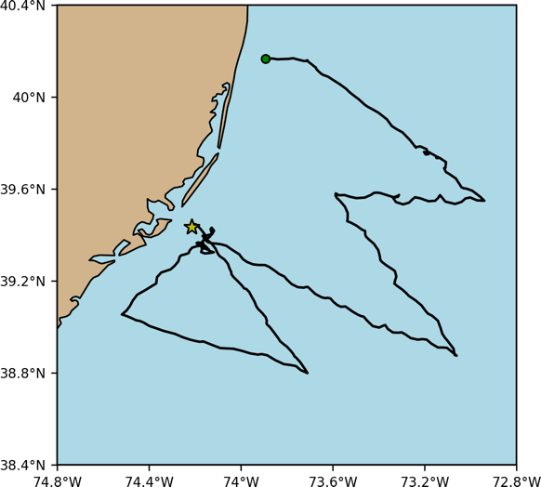
Glider deployments: We have conducted a total of 18 glider deployments for this project, 3 in the current reporting period. We conducted a paired Spring 2023 mission (4/20 - 5/12; previous reporting period – June 2023 report), two single-glider gap fill missions (06/29 - 08/02 and 09/20 - 10/19; previous reporting period – November 2023 report), a paired glider Summer 2023 mission (08/17 - 09/20; previous reporting period – November 2023 report), a paired glider Fall 2023 mission (11/03 – 12/05; previous reporting period – November 2023 report), a paired glider Winter 2024 mission (02/15 - 03/14; previous reporting period – April 2024 report), a paired glider Spring 2024 mission (04/29 – 05/29; previous reporting period – September 2024 report), a single-glider gap fill mission (06/12 – 07/09; previous reporting period – September 2024 report), a paired glider Summer 2024 mission (07/23 – 08/23; previous reporting period – September 2024 report), a single-glider gap fill mission (09/04 – 10/05; this report), and a paired glider Fall 2024 mission (10/21 – 11/19; this report). These 18 deployments conclude two full annual cycles of data collection. The approximate path taken for each glider mission is indicated in the figure (right), and sensors aboard each glider and mission are included in the table below. Details of the data collected over the Spring, Gap-Fill, and Summer 2024 missions are described in greater detail below in ‘Preliminary Results’.

Additionally, we have recently begun pairing the RMI-funded deployments with the other nearshore glider deployments funded by NJDEP’s Bureau of Marine Water Monitoring. We have also added a pH sensor to the nearshore glider (at no cost to this project) to not only expand the spatial coverage of the carbonate chemistry monitoring, but also to address and monitor for potential multi-stressor conditions (low pH/Ω and dissolved oxygen) that were observed during the summer 2023 missions.

Deployment time | Glider name | Parameters measured
 |  | Salinity, Temperature, Depthª | pH^{b} | Chlorophyll, backscatter, CDOM^{c} | Dissolved oxygen^{d} | Zooplankton biomass (active acoustics)^{e} | Fish biomass (active acoustics)^{f} | Marine mammal detection^{g} | Tagged fish detection^{h}
Spring 2023 | ru39 | X | X | X |  | X |  |  | X
Spring 2023 | ru41* | X |  | X | X |  |  | X | X
Gap fill: July 2023 | ru40 | X |  | X | X |  |  | X | X
Summer 2023 | ru39 | X | X | X |  |  | X |  | X
Summer 2023 | ru40 | X |  | X | X |  |  | X | X
Gap fill: Sept 2023 | ru34 | X | X | X | X |  |  |  | X
Fall 2023 | ru39 | X | X | X |  | X |  |  | X
Fall 2023 | ru40 | X |  | X | X |  |  | X | X
Winter 2024 | ru39 | X | X | X |  | X |  |  | X
Winter 2024 | ru40 | X |  | X | X |  |  | X | X
Spring 2024 | ru39 | X | X | X |  | X |  |  | X
Spring 2024 | ru40 | X |  | X | X |  |  | X | X
Gap fill: June 2024 | ru43 | X | X | X | X |  |  |  | X
Summer 2024 | ru39 | X | X | X |  |  | X |  | X
Summer 2024 | ru40 | X |  | X | X |  |  | X | X
Gap fill: Aug 2024 | ru43‡ | X | X | X | X |  |  |  | X
Gap fill: Sept 2024 | ru43 | X | X | X |  | X |  |  | X
Fall 2024 | ru39 | X | X | X |  |  | X |  | X
Fall 2024 | ru40 | X |  | X | X |  |  | X | X
Winter 2025 | ru39 | X | X | X |  | X |  |  | X
Winter 2025 | ru40 | X |  | X | X |  |  | X | X
ªSensor = Deployment completed
ªSensor = Deployment ongoing
ªSensor = Deployment missed (see ‘Difficulties Encountered’ section below)
ªSensor = Sea-Bird CTD
^{b}Sensor = deep-sea ISFET based pH sensor, coupled with ªCTD
^{c}Sensor = Wetlabs FLBBCD-SLC ECOpuck
^{d}Sensor = Aanderaa optode
^{e}Sensor = ASL Acoustic Zooplankton Fish Profiler (AZFP), a multi-frequency echosounder configured for zooplankton (120, 200, 455, 769 kHz)
^{f}Sensor = ASL Acoustic Zooplankton Fish Profiler (AZFP), a multi-frequency echosounder configured for pelagic fishes (38, 120, 200 kHz)
^{g}Sensor = WHOI DMON
^{h}Sensor = Vemco Rx-Live or Vemco VMT
*glider lost; replacement ordered
‡ru43 = new glider (replacement to lost glider ru41)

General note on above table: While the deployment schedule and sensors that will be targeted for use during those deployments are more concrete, glider names and their respective deployment assignments listed above are tentative and will be based on which gliders are available based on glider and sensor bay maintenance schedules.

Developments in real-time data visibility: As part of our ongoing effort to ensure real-time data availability, we added calculations of Total Alkalinity and Aragonite Saturation State for the New York Bight region to our glider data processing pipeline. These data products are available in our real-time datasets that are distributed on RUCOOL's glider ERDDAP server. The code for these improvements is publicly available in our rugliderqc Github repository.

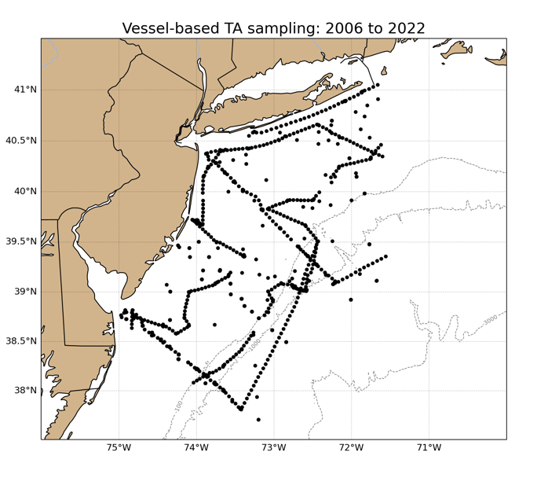
In order to complete this we updated our Total Alkalinity (TA)-salinity regression analysis to incorporate more vessel-based data in the New York Bight region. The previous analysis included discrete samples collected during the summer 2015 East Coast Ocean Acidification (ECOA) cruise. This dataset was paired with water sampling done during seasonal glider deployments and recoveries, and the linear relationship between TA and salinity was calculated for each season. Any seasonal differences in the TA-salinity relationship were based solely on the glider-based water sampling due to a lack of vessel-based data.
To incorporate more vessel-based data into the analysis, we used the 2021 CODAP-NA dataset in addition to publicly available cruise data downloaded from the NCEI Ocean Carbon and Acidification Data System (OCADS) data portal. These datasets were filtered to include sampling locations within the New York Bight at depths less than 200m (maximum glider depth), and salinity/TA QC flags were applied (when available).
The resulting vessel-based New York Bight dataset includes Niskin bottle samples as well as surface flow-through and underway samples from 31 oceanographic cruises from 2006-2022. This expansion of the vessel-based dataset now allows for more robust seasonal TA-salinity regressions that are used to estimate TA in glider datasets.

Data product development: The resulting data from the project’s first year of deployments is starting to be utilized for research and the development of data products by data analysts from our Masters in Operational Oceanography program. Masters students Nicholas Occhiogrosso and Scott Pescatore recently finished their theses (included with this report as Appendix 1 and 2, respectively), and are briefly summarized here.

Nicholas focused his thesis on describing initial trends in zooplankton distribution using the RMI glider active acoustic data (Spring 2023, Fall 2023, and Winter 2024), and he conducted a preliminary analysis to determine if oceanographic conditions were related to spatial and/or seasonal zooplankton distribution on the shelf. Zooplankton spatial distributions along the glider transects were relatively homogenous in spring and winter, but in the fall, zooplankton spatial distributions were more concentrated in deeper isobaths over the mid- to outer-shelf. Zooplankton abundance and biomass were lowest in the spring. In fall, the highest depth-integrated biomass and abundance values were in the mid- and outer-shelf waters, while in the spring and winter seasons, highest values were nearshore. His preliminary analysis determined no statistically significant correlations between zooplankton abundance/biomass values and measured oceanographic variables. However, his initial analysis was very broad and did not include co-binning of both zooplankton and oceanographic data in vertical or temporal space (surface v. subsurface; day v. night). Also, it is most likely that specific oceanographic variables like temperature or salinity would not necessarily predict zooplankton spatio-temporal resolution, but more likely convergence features (e.g., fronts) would act to aggregate (increase biomass) or dis-aggregate (decrease biomass). Our group has transitioned to a new ocean front product that assimilates observed HF radar data and derives location of surface shelf water convergence zones – specifically Lagrangian Coherent Structures called Finite Time Lyapunov Exponents or FTLEs – at daily resolutions. PI Saba and her group are currently expanding our correlative analysis and applying this new ocean front product to these RMI glider zooplankton datasets as well as the most recent datasets in a manuscript that is currently in prep.

Scott Pescatore developed software tools and utilized VEMCO telemetry data from five previous (non-RMI) glider deployments on the New Jersey shelf to investigate how tagged fish distributions were related to satellite-derived oceanographic features (specific water masses, frontal locations). 66% of tagged fish detections, primarily those of Atlantic sturgeon and striped bass, occurred near strong ocean fronts. However, his dataset was limited by the lack of RMI glider data at the time of his analysis as well as the lack of most recent satellite-derived ocean front data product (beyond October 2022). Our group has now received several RMI glider MATOS datasets that we can now work with. Additionally, our group has transitioned to a new ocean front product (daily HF radar data-derived convergence zones) that will be used in place of the satellite-derived ocean front product that is now out of operation. The tools Scott developed can be applied to the RMI glider telemetry data and provide routine products that present the overlap of these ecological trophic groups to observed ocean characteristics and features.

Additionally, the marine mammal data collected through the glider passive acoustic sensors are contributing to the larger community effort to inform probability maps of North Atlantic Right Whales in and around planned offshore wind projects.

Data Availability: The data are reported in two ways. Real-time data are those data sent back to shore via the satellite connection during the mission and may not include the full dataset. Delayed mode data are those data recovered from the glider once it is recovered and include the full dataset. The QA/QC associated with both data reporting are described in the project QAPP document. The status of data reporting for each mission is summarized below.
- Spring 2023 paired
  - ru39: delayed mode data are available on ERDDAP
  - ru41 (lost): real-time raw data are available on ERDDAP
- June/July 2023 gap-fill
  - ru40: delayed mode data are available on ERDDAP
- Summer 2023 paired
  - ru39: delayed mode data available on ERDDAP
  - ru40: delayed mode data available on ERDDAP
- September/October 2023 gap-fill
  - ru34: delayed mode data available on ERDDAP
- Fall 2023 paired
  - ru39: delayed mode data available on ERDDAP
  - ru40: delayed mode data (pre-brake failure) and delayed mode data (redeploy after fix of glider brake) available on ERDDAP
- Winter 2024 paired
  - ru39: delayed mode data available on ERDDAP
  - ru40: delayed mode data available on ERDDAP
- Spring 2024 paired
  - ru39: delayed mode data available on ERDDAP
  - ru40: delayed mode data available on ERDDAP
- June 2024 gap-fill
  - ru43: delayed-mode data available on ERDDAP
- Summer 2024 paired
  - ru39: delayed-mode data available on ERDDAP
  - ru40: delayed-mode data available on ERDDAP
- September 2024 gap-fill
  - ru43: delayed-mode data are available on ERDDAP
- Fall 2024 paired:
  - ru39: delayed-mode data available of ERDDAP
  - ru40: delayed-mode data available on ERDDAP
- Winter 2025 paired (currently deployed)
  - ru39: real-time raw data available on ERDDAP
  - ru40: real-time raw data available on ERDDAP

Preliminary Results:

Oceanographic data

Seasonal progressions: Starting with the first glider deployments for this project up until the date of this progress report, RMI gliders were in coastal shelf waters 280 out of 517 days (54% coverage) and traveled 5300 km. This reporting period started with the paired Spring 2024 mission, which notably observed anomalously cold bottom water temperatures. The minimum bottom temperature during the Spring 2024 mission was measured at 6.02˚C, and the Cold Pool minimum temperature stayed near or below 7˚C through the gap fill and Summer 2024 missions. Average Cold Pool temperature during this time of year is typically between 8-10˚C. Also, stratification set up was observed during the paired Spring 2024 mission (end of May), and this seems to have occurred at 1 month or more later than the previous year (end of April 2023). Maximum surface temperatures during the Summer 2024 deployment reached 26.1 ˚C. Bottom seawater pH and Ω during Summer 2024 were the lowest we have observed in our history of glider-based ocean acidification monitoring (since 2018). Minimum bottom pH values (7.6) and Ω values (0.64) covered a large proportion of the shelf, particularly in the shallower areas. However, bottom dissolved oxygen remained above 5 mg/L. We attribute the low bottom temperature, pH, and Ω, and relatively high dissolved oxygen, to an unusually high volume flux of Labrador Slope Water onto the MAB shelf this year,.

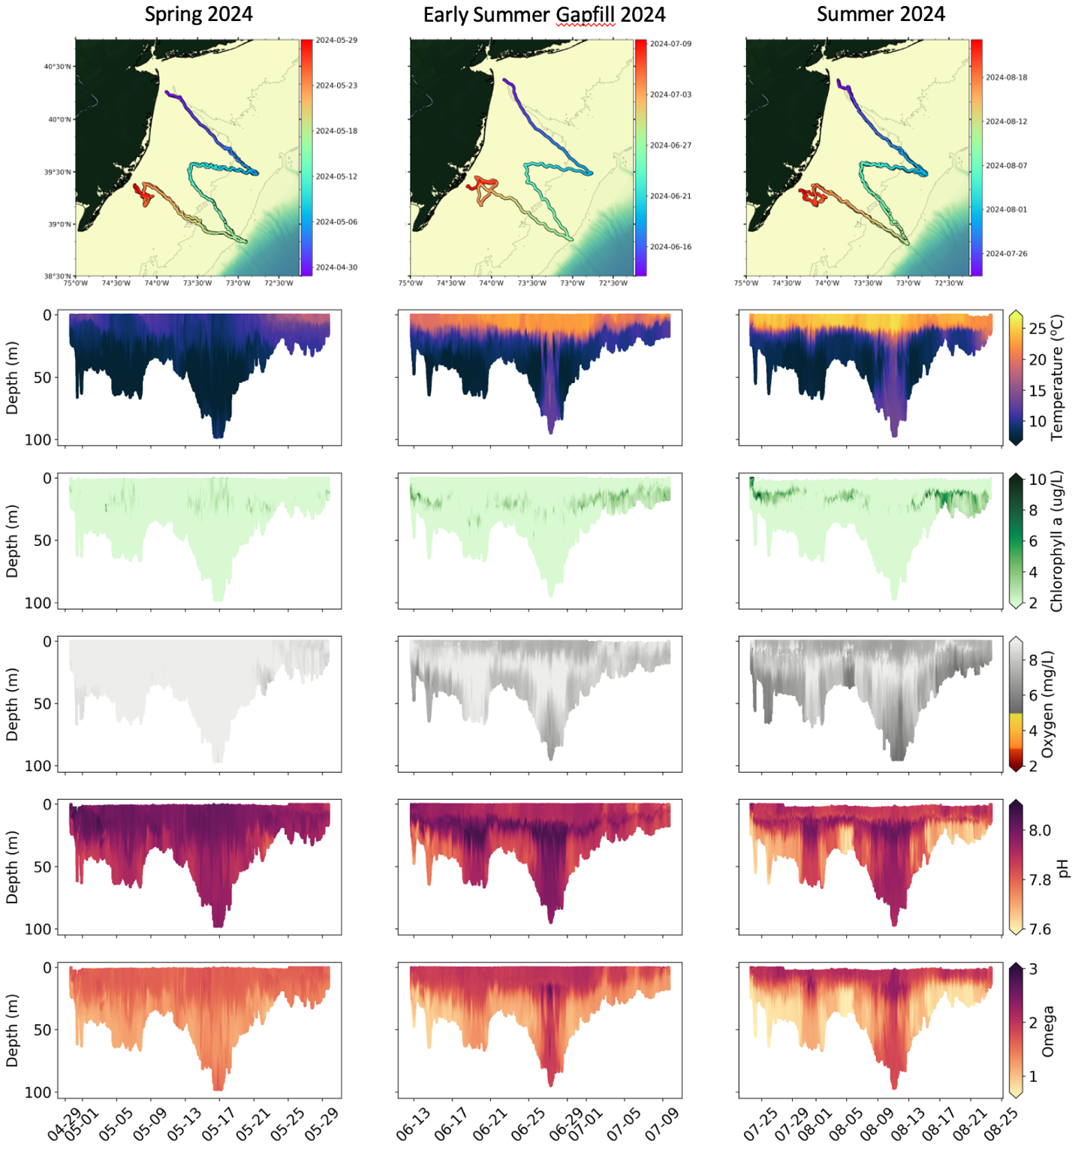
Complete cross-sections of (from top to bottom) temperature, chlorophyll concentrations, dissolved oxygen concentrations, pH, and derived aragonite saturation state (Omega) measured along the mission tracks during the Spring 2024 (left panel), Early Summer gapfill 2024 (center panel), and Summer 2024 (right panel) glider deployments.

Acoustic data

Passive acoustic data: The passive acoustic data and the status of data retrieval and processing are summarized in the table below. Locations for marine mammal detections can be viewed on the links provided in the table below, and these are also openly accessible at http://robots4whales.whoi.edu/.

Deployment/glider name | Vemco detection data info and/or status | DMON detection data info and status
Spring 2023 paired
ru39 | No vemco detections | N/A. No DMON sensor.
ru41 | No vemco detections | 3 humpback detection days
Early summer (June/July) 2023 gap fill
ru40 | 84 detections from 8 unique tags registered in the MATOS database, 25 detections from 2 unique tags not registered in the MATOS database | 2 fin whale detection days
Summer 2023 paired
ru39 | 26 detections from 5 unique tags registered in the MATOS database, 8 detections from 1 unique tag not registered in the MATOS database | N/A. No DMON sensor.
ru40 | 71 detections from 11 unique tags registered in the MATOS database, 11 detections from 3 unique tags not registered in the MATOS database | 18 fin whale detection days
Early fall (September/October) 2023 gap-fill
ru34 | 849 detections from 46 tags (preliminary from Rx-Live), official results and contact points waiting on next MATOS data push | N/A. DMON swapped for pH to continue monitoring dissolved oxygen and pH
Fall 2023 paired
ru39 | 13 detections from 3 unique tags registered in MATOS database, 44 detections from 11 unique tags not registered in MATOS database | N/A. No DMON sensor.
ru40 | 56 detections from 12 tags (preliminary from Rx-Live), official results and contact points waiting on next MATOS data push | 15 total whale detection days including fin whales (11 detection days), humpback whales (2 detection days), and North Atlantic right whales (NARW, 5 detection days). *Note: Due to the detection of NARW presence from this glider, NOAA Fisheries triggered a voluntary Right Whale Slow Zone in the detection area that started on 11/17 and was effective until 12/2.
Winter 2024 paired
ru39 | 18 detections from 4 tags not registered in MATOS database | N/A. No DMON sensor.
ru40 | 140 detections from 12 tags (preliminary from Rx-Live), official results and contact points waiting for next MATOS data push | 24 total whale detection days including sei whales (1 detection day), fin whales (19 detection days), and humpback whales (16 detection days).
Spring 2024 paired
ru39 | No Rx-Live data. Awaiting VMT data from next MATOS data push (October). | N/A. No DMON sensor.
ru40 | 372 detections from 35 tags (preliminary from Rx-Live), official results and contact points waiting for next MATOS data push (October) | 22 total whale detection days, including sei whales (12 detection days), fin whales (14 detection days), right whales (1 detection day), and humpback whales (22 detection days)
Early summer (June/July) 2024 gap-fill
ru43 | No Rx-Live data. Awaiting VMT data from next MATOS data push (October). | N/A. No DMON sensor.
Summer 2024 paired
ru39 | No Rx-Live data. Awaiting VMT data from next MATOS data push (October). | N/A. No DMON sensor.
ru40 | 565 detections from 36 tags (preliminary from Rx-Live), official results and contact points waiting for next MATOS data push (October) | 19 total whale detection days, including sei whales (1 detection day), fin whales (19 detection days), right whales (2 detection days), and humpback whales (5 detection days); right whale detections initiated a slow zone

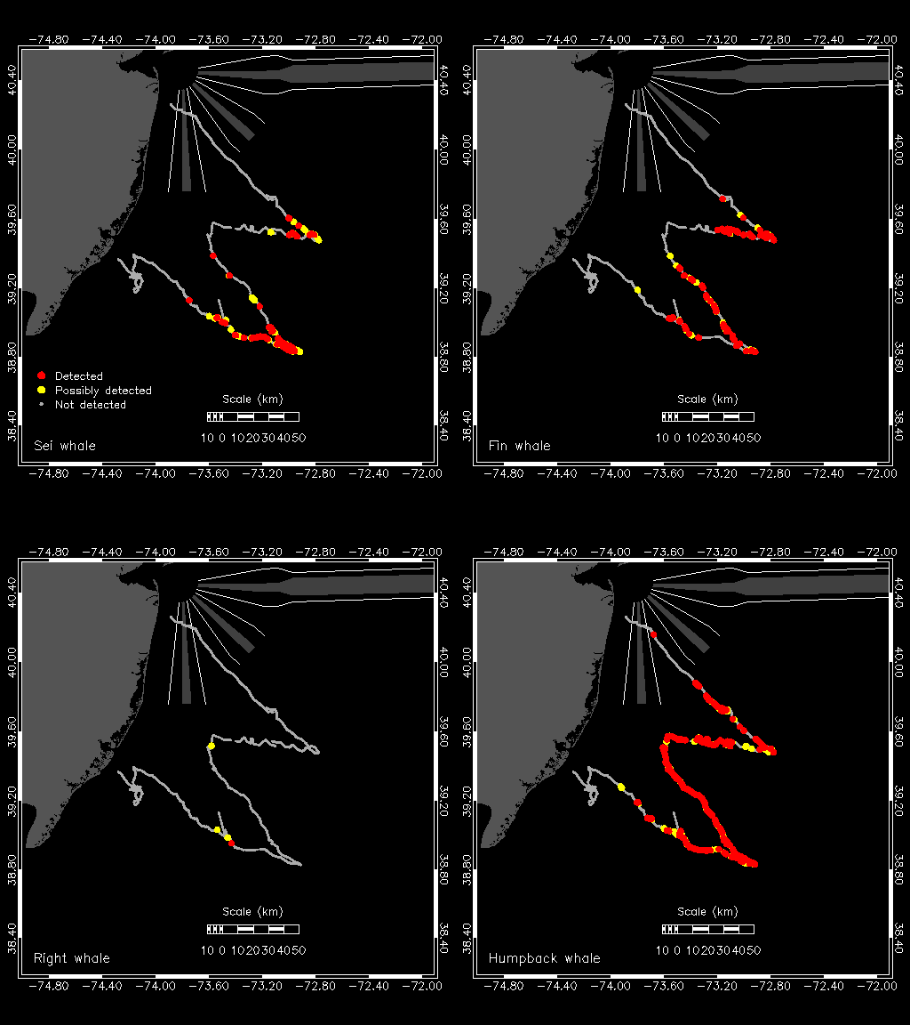
Marine mammal detections observed during the Spring 2024 glider mission.

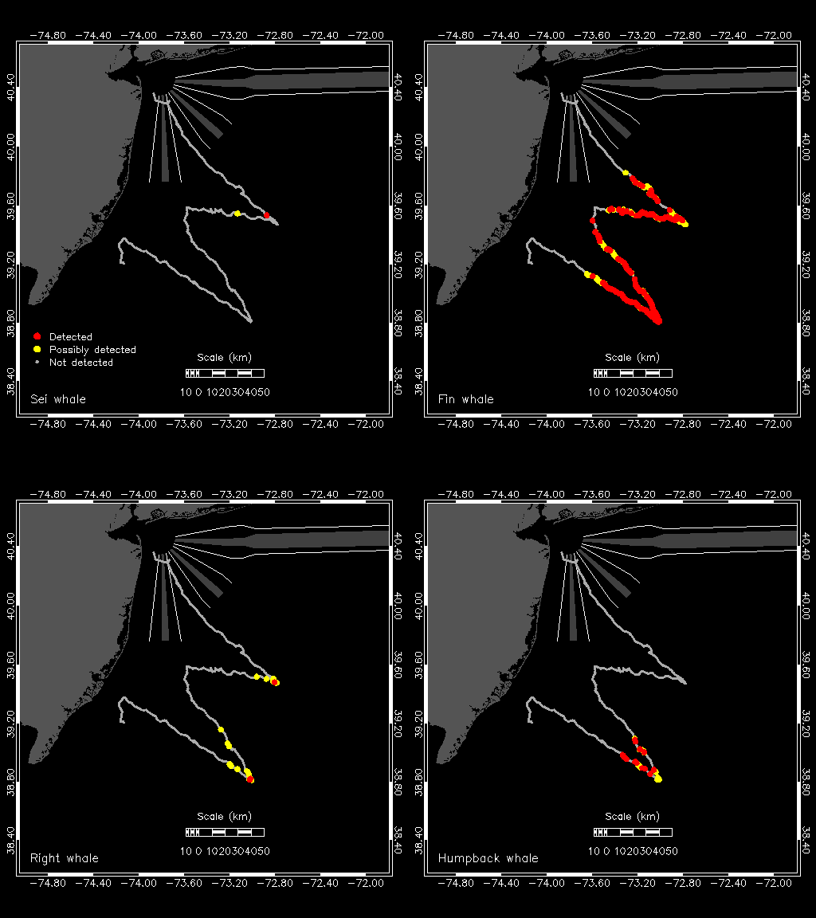
Marine mammal detections observed during the Summer 2024 glider mission.

Active acoustic data: Active acoustic data from the glider AZFP sensors have been initially processed and analyzed for the Summer/Fall gapfill and Fall 2024 paired missions, but we are still in the process of quality control and refining the analyses. Specifically, we are gathering NJDEP trawl data to identify potential common pelagic fish scatterers, which will allow for estimates of concentration and biomass estimates; for now, all data regarding fish backscattering is presence/absence only. The sensor calibration data obtained in January 2024 were applied to the processed backscatter data for these datasets.We performed another calibration in January 2025, the results of which will be applied to datasets going forward.

Summer/Fall 2024 zooplankton distribution was very patchy, with high concentrations of small and large copepods along basin edges between 30-75 m in depth. [numbers about percentage contribution to biomass and total zooplankton biomass here]

An unusual scattering pattern was observed in the Fall 2024 scattering data, consisting of a diffuse cloud that appeared in the water column around nightfall and disappeared around sunrise. The behavior of this cloud is consistent with several species that undergo diel vertical migration; analysis is still being carried out to determine the specific organisms that made these echoes based on their acoustic characteristics. Beyond that, we observed echoes consistent with gelatinous zooplankton and fish both with and without swim bladders. Most of these echoes were concentrated towards the seafloor, but some were located in the middle of the water column.

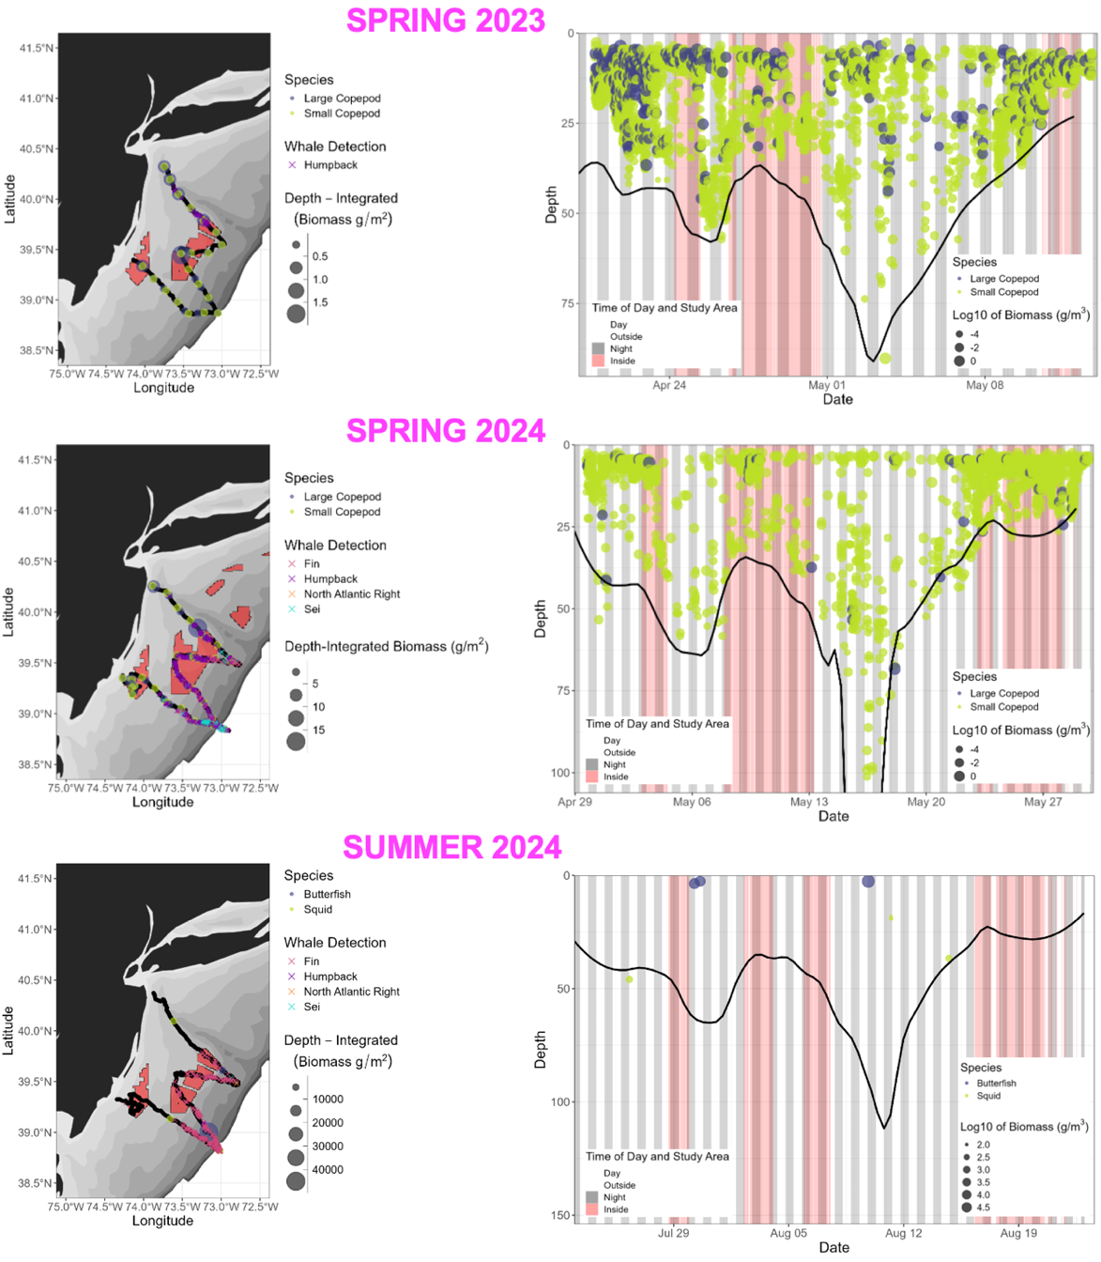
Estimated zooplankton biomass from Spring 2023 and 2024, and estimated biomass of pelagic fishes and squid from Summer 2024 paired missions. Left panels: Depth-integrated total zooplankton or fish/squid biomass (g/m²) measured along glider transects along with marine mammal detections. Wind lease areas highlighted in salmon color. Right panels: Zooplankton or fish/squid biomass (log₁₀; g/m³) estimated from the Spring 2023, Spring 2024, and Summer 2024 paired missions over deployment time and depth (in meters). The figure indicates daytime (white) and nighttime (gray bars) as well as locations where sampling was conducted inside (pink bars) or outside (white) wind farm lease areas. The seafloor is indicated by the solid black line (note: these depth data are interpolated/smoothed, and thus some biomass data points may appear below the seafloor). For Spring missions, the biomass data includes only that from copepods, and the dominant zooplankton (scatterers) identified in the replicate zooplankton net tows that were conducted at glider deployment and recovery included the small copepods Paracalanus parvus, Oithona similis, and Centropages typicus and large copepod Calanus finmarchicus.
Difficulties Encountered:
ru39 was recovered from the Fall 2024 paired mission with a missing port wing and broken wing rail. Need more details.

Presentations & Publications (includes only this reporting period):
Occhiogrosso, N.S. 2024. Glider-observed seasonal and spatial distributions of zooplankton in the Mid-Atlantic Bight. Thesis for the Master of Operational Oceanography Program. Graduate Program in Oceanography, Rutgers University. 20 p. Appendix 1.
Pescatore, S. 2024. Associating fish tag detections to satellite derived water masses and ocean front gradients. Thesis for the Master of Operational Oceanography Program. Graduate Program in Oceanography, Rutgers University. 19 p. Appendix 2.
Saba, G. 2024. Why measure coastal acidification? What can it tell us? Insight from a New Jersey case study. Invited talk presented at the Mid-Atlantic Ocean Acidification Workshop. September 2024. Baltimore, MD.
Kohut, J.T., McGarigal, C., Lawrence, K., Saba, G.K. 2024. An autonomous-based oceanographic and ecological baseline to inform offshore wind development. Talk presented at the Underwater Gliders User Group Workshop. September 2024. Ann Arbor, MI.
Garzio, L., Nazzaro, L., Kohut, J.T., Saba, G.K. 2024. 2023 Seasonal Mid-Atlantic Ocean Temperatures and Stressors. Talk presented at the State of the Climate: New Jersey 2023 webinar. July 2024. Virtual.
Saba, G.K., McGarigal, C., Lawrence, K., Kohut, J.T. 2024. An autonomous-based oceanographic and ecological baseline to inform offshore wind development. Poster presented at NYSERDA’s State of the Science 2024 Workshop Taking an Ecosystem Approach: Integrating Offshore Wind, Wildlife, and Fisheries. July 2024. Long Island, NY.
Kohut, J.T., McGarigal, C., Lawrence, K., Saba, G.K. 2024. An autonomous-based oceanographic and ecological baseline to inform offshore wind development. Talk presented at the International Underwater Glider Conference. June 2024. Gothenburg, Sweden.
Kohut, J.T., McGarigal, C., Lawrence, K., Saba, G.K. 2024. An autonomous-based oceanographic and ecological baseline to inform offshore wind development. Talk presented at the Mid-Atlantic Ocean Forum. May 2024. Lewes, DE.

Drinkwater, K.F., Petrie, B., Smith, P.C. 2002. Hydrographic variability on the Scotian Shelf during the 1990s. Northwest Atlantic Fisheries Organization Scientific Council Meeting, June 2002. Serial No. N4653, NAFO SCR Doc. 02/42, https://www.nafo.int/Portals/0/PDFs/sc/2002/scr02-042.pdf.
Record, N., Pershing, A., Rasher, D.B. 2024. Early warning of a cold wave in the Gulf of Maine. Oceanography, https://doi.org/10.5670/oceanog.2024.506.

